Appendix 6 – Extracts from Latimer’s published accounts for the year ending 31/3/2022
(The whole document is available at Companies House)

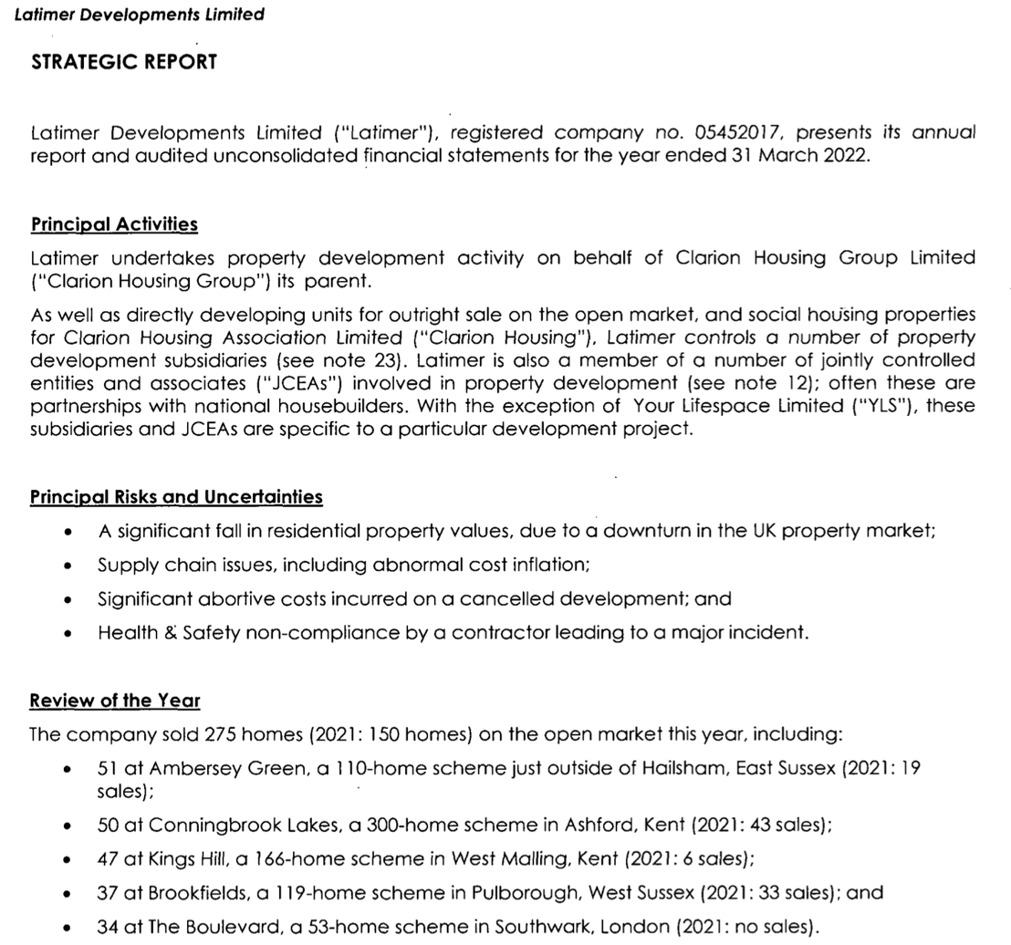

Comment: Latimer’s biggest development delivered just 51 dwellings in the year. The Gerald Eve appraisal assumes that 250 dwellings per annum can be delivered consistently, a big step up for Latimer.

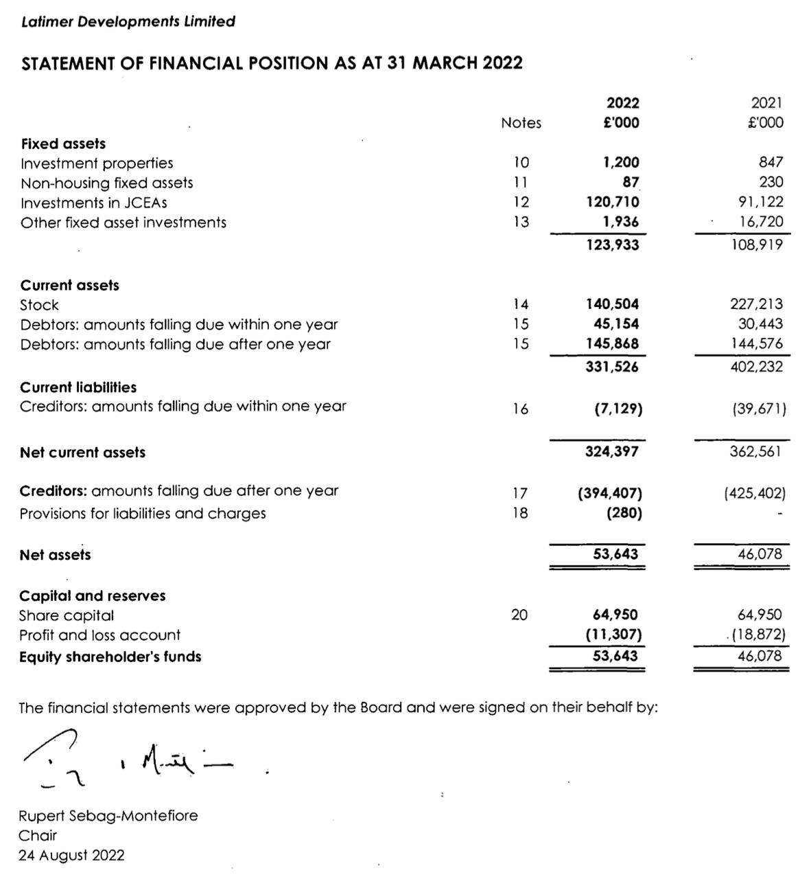

Comment: Latimer’s balance sheet shows high gearing and net assets of £53m. It isn’t strong enough to support a £300m cash commitment over 35 years and a holding company guarantee will be required unless the development is broken into more manageable phases.

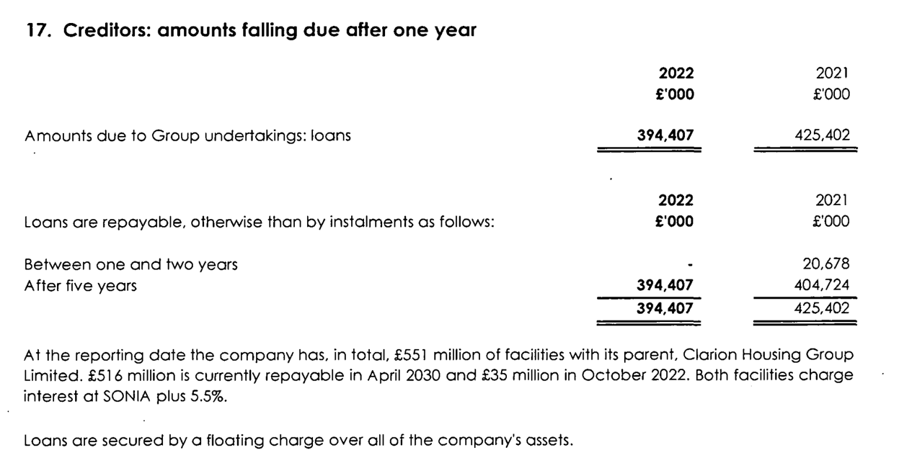

Comment: Latimer’s debt is provided by the Clarion group on armslength terms, indicating financial discipline within the group. SONIA plus 5.5% is high, but not unreasonable for risky lending to a property developer.

SONIA is the replacement for LIBOR. It stands for “Sterling OverNight Interest Average”.

