Colchester’s Garden Community

Response to the Reg 19 consultation on the DPD on TCBGC

William Sunnucks
24 June 2023

Introduction

I am not against TCBGC but I have serious concerns about whether the plan will be “effective” i.e. all the promises delivered. I try to add positive ideas about how each weakness might be resolved, grouped into two sections:
- Modifications - the modifications needed to the DPD and
- Delivery - whether the planning will be effective in delivering the DPD promises

My response is supported by the following evidence:
Appendix 1: New towns – the track record
Appendix 2: Financial viability
Appendix 3: Colchester’s resolution explained
Appendix 4: TCBGC – existing land ownerships
Appendix 5: Cash contributions required from Latimer
Appendix 6: Extracts from Latimer’s published financial accounts
Appendix 7: Other precedents:
- 7.1 Master Developer Business Model – Urban & Civic
- 7.2 Consequences of unviable phase 1 – Welborne

I can’t see how the DPD can be found to be “sound” or “effective” until the commercial issues are addressed and the compromises needed are identified, modelled and acknowledged in the DPD. Compromises to be considered might include i) cutting back on the offsite transport infrastructure ii) relaxing part L & F requirements which are adding 10% to the housebuild costs and iii) cutting back on social housing numbers. I don’t endorse any of these options – I’m just following the numbers and advocating the preparation of a phase 1 appraisal to bring the project down to earth. It is for others to decide the priorities.

Modifications:
Chapter 1 - INTRODUCTION
Legal status of Section 1 plan: we need a clear statement that the Section 1 plan will remain in full force after the DPD is adopted - if there is already such a statement I can’t find it. This is important because the wording of the DPD is often weaker than the Section 1 plan, especially in policy GC9. Examples of protections that will be lost if the section 1 plan is overwritten by the DPD are:

- Water quality: the local plan (SP8 and SP9) requires increased water treatment capacity, but the DPD makes no mention so the promise will be lost.
- Speculative development: the section 1 plan (para 8.5) provides protection against speculative development if the GC fails by stating that “Development is unacceptable in the absence of GC principles”. This critical protection is left out of the DPD and will be lost unless the status of the section 1 plan is reinforced.
- Phasing: the Section 1 plan repeatedly refers to the need for a phasing plan in the DPD (see SP6 for example). But the DPD has very little about phasing, and no link to the IDPFP. It doesn’t mention the key 2200-2500 dwellings deliverable in the Local Plan period or the agreement to split the number evenly between the Councils (SP8). It seems that these matters are to be deferred until a planning application comes forward.

We also need a statement making it clear that the policies of the Section 1 plan are intended to apply throughout the garden community build period. The section 1 plan only extends to 2033 whereas the DPD purports to apply until 2058

Future powers of the Councils:
Once the DPD is adopted Colchester will have no power to stop further compromises being made. It has already been forced to accept the phased link road and when it loses its planning powers any remaining power will be gone. It will be in a minority on a Joint Committee where Tendring and ECC Councillors will be in the majority.

This is why Colchester needs every protection it can get, and if they aren’t provided it would be justified in refusing to adopt the DPD.

The arrangements between Colchester and Tendring also need further clarification before the DPD is adopted. It needs to be clear that Colchester will have half the social housing nomination rights and half the housing numbers in perpetuity. Also half the business rates collected and half of any new homes bonus or other grants. There are many other items which could cause discord and should be resolved before Colchester hands over its last negotiating card.

Future timetable
My understanding of the timetable envisaged is shown below. I am concerned that the practical commercial issues are lagging too far behind the planning. Waiting for a planning application before resolving s106 processes is irresponsible and disrespects the Viability PPG.
Document | Design issues | Commercial issues
DPD | Subject to Inspection and three Councils’ approval | Not included - leave until planning application
Garden Community Level Masterplan and design code | Subject to three Councils’ approval | -
Neighbourhood level Masterplan and design code | Subject to three Councils’ approval | -
Planning application | To be prepared by Clarion/Latimer the appointed developer | To include heads of terms for developer contributions.
Planning permission granted | Delegated to the Joint Committee. | Delegated to the Joint Committee.

Duty to co-operate
Most of the housing will be built in Tendring but the infrastructure burden will fall on Colchester. Serious seeds of dispute lie in that simple fact and they need to be better addressed if the duty to co-operate is to be met over the years.

So far there is only a short memorandum of understanding between Colchester & Tendring agreeing to share housing numbers during the plan period. This arrangement was acknowledged and supported at the Section 1 examination but was very limited in scope (see para 63 of the Inspector’s report and MM30).

A more detailed document is needed at this DPD stage, including the following elements:
- Agreement on housing numbers beyond the plan period (s/b 50/50)
- Agreement on social housing nomination rights (s/b 50/50)
- Agreement to split any other income or receipts relating to TCBGC, including business rates
- Agreement on future planning and management cost sharing (ECC, Tendring Colchester)

Chapter 2 – Vision
The DPD still gives no feel for the appearance or character of the GC. Inspector Clewes recommended a “three dimensional indication of the urban design and landscape character” but there has been little or no progress. Three D modelling together with some illustrations like the one below would help, as would an agreed name for the settlement.

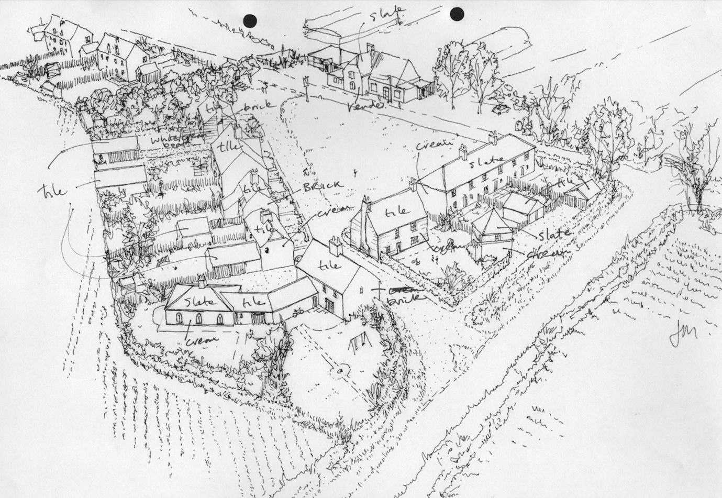

Garden Community Principles: there is inconsistency between the first and third principles on page 14 and the reality on the ground.

Garden Community principles require Land Value Capture, but there is no practical plan to achieve this. By now the principles should be documented in a further MOU with Latimer, as requested by Colchester City Council in their resolution.

And GC principles require Community ownership of the land, but the land is owned by third parties (See Appendix 4). By now the developer should have agreed in principle (in the MOU) to run the common parts until each part of the development is completed and then hand over ownership and management to some community based body, yet to be determined. It should be clear that the community has the right but not the obligation to manage the Country Park and the extensive areas of green and blue infrastructure.

By now some thought should have been given by now to the following issues which may cause controversy in the future:
- At what point will governance move from the existing parishes to a new town body?
- How will one community body respond to two different Councils – Colchester and Tendring.

The viability appraisal deals with all this by simply setting aside a sum of £15.7m for stewardship with no further detail.

Policy GC1 – Land Use
I have three comments:

Clinghoe Hill: I’m worried that the knowledge-based employment land is too close to Clinghoe Hill. Part G needs to require that the buildings are set back, limited in height and landscaped to ensure that the area has a rural or “garden” feel. The objective should be to make the buildings scarcely visible from the road once the surrounding trees reach maturity. My suggestion is consistent with policy SP6 which requires appropriate buffers along strategic roads.

Growing Food: Garden Communities are meant to have opportunities for growing food. Land needs to be set aside for allotments or bigger gardens and the viability numbers adjusted accordingly.

Severance of employment land
The new Business Park is to be located to the East of the site, separated by the link road. I worry that the severance will force people unnecessarily into their cars. While this is necessary for heavy B8 type uses, many jobs are now in offices and workshops which do not need to be severed from housing. The proposed segregation of the Business Park is not justified.

I suggest that the key diagram in the DPD be changed to
- integrate some of the B1 employment land better with residential to the West of the link road
- relocate the A120 service station into the employment land on the link road, a solution that would work better providing access to the existing service station along a service road
- indicate how the Knowledge Based Employment site alongside the A133 will be accessed by road

Policy GC2 – Nature
Biodiversity net gain: it isn’t clear how 10% BNG will be achieved on site and I suspect it can’t be done.
- The Salary Brook country park will be on the attractive slopes to the Brook which already has high value: so BNG points will be lost when it is open to the public – a key promise in the DPD. There is conflict between the use of Salary Brook as a Nature Reserve and as a Country Park
- Much of the remainder of the site will put farmland and hedgerows under concrete and I would expect a net BNG loss there too.

The evidence base needs a proper BNG assessment using the latest DEFRA metric. If 10% is unachievable then the plan should be changed, or budget included for the purchase of offsite BNG units. It is important that the assumptions in the BNG assessment align with the assumptions in the viability appraisal. Also that 10% BNG is achieved for each phase not as a distant promise.

Policy GC3: Buildings, Places and Character
Naming: the Garden Community urgently needs a name if it is to have its own recognisable identity. Scarcely anyone has heard about Colchester’s biggest development and TCBGC is a mouthful to explain on the doorstep. I suggest that a shortlist be prepared and put out to consultation with the public.

Policy GC4: Meeting housing needs
Social housing: Part B requires 30% social housing, but the viability evidence presented suggests that it isn’t achievable, especially when up to date house prices, build costs and interest rates are used (see appendix 2 to my report).

Precedent sites at Alconbury and Welborne (Fareham) achieved 12.5% and 10% respectively in their early phases (see appendix 7 to my report).

The compromises needed should be identified and incorporated within the plan as per the Viability PPG, otherwise it cannot be found sound. The Viability PPG makes it clear that viability issues should be resolved at plan making stage, not left to the planning applications.

Policy GC5: Economic Activity and Employment
No comments

Policy GC6: Community and social infrastructure
I support the concept of three neighbourhoods each with its own centre and primary school.

I’m concerned that GC Policy 6 is too vague.
- Parts A, B and C are strong and clear, but they need to link into the phasing in the Infrastructure Delivery Plan.
- Part D needs to be more place specific – it refers to a wider sports strategy, not the GC.
- Part E (health) is wholly inadequate. We need specific commitments from the developer and the NHS for the funding of GP and hospital facilities to meet the needs of the community.

I fear that health provision will fall far behind population growth, and that surrounding communities will be adversely affected.

Policy GC7: Movement and connections
Road capacity: The RTS is to run along the already congested Clinghoe Hill route. I’m concerned that it will cause further tailbacks for cars, and believe that the circular route suggested by the Community Liaison Group should be considered as an alternative.

Traffic modelling: I was very concerned to hear that the traffic modelling didn’t need to be changed for the phasing of the link road. It undermines the credibility of the modelling: clearly the link road is fundamental to TCBGC’s sustainability and any delay in its delivery will cause major traffic problems.

Modal shift: Progress has been made on planning the rapid transit system, but the modal shift assumptions are too optimistic. I cannot see how the proposed RTS will attract sufficient usage unless it can be competitive in terms of cost, time and convenience. The only way to achieve material modal shift without deliberately creating traffic jams is to bring in congestion charging, something not remotely on the political agenda.

The A120/A133 Link Road: Colchester was forced to accept the phased approach to the link road at the last minute, too late to consider alternative solutions. The developer is only promising to complete the second (and more complex) phase “when it is practically and financially possible to do so”.

At present Colchester’s only protection comes from the Section 1 Plan which states that “Before any planning approval is granted for development ….. the following strategic transport infrastructure must have secured planning consent and funding approval
- A120-A133 link road: and
- Route 1 of the RTS ….”

Planning consent has already been granted, and the developer may well argue that it has received funding approval from its parent. But it could be years before anything is actually delivered.

Colchester’s concerns were expressed in a rare formal resolution from the full Council. The Joint Committee should recognise them and formally ask the Inspector to add two new restrictions to those in the Section 1 plan:
- No new housing can be started until both phases of the A120-A133 link road are started on site, and
- no more than ….. dwellings can be occupied before the link road is completed and operational.

Policy GC8 – Sustainable infrastructure
Part L and F build costs: 10% has been added for extra Part L and F build costs in the Gerald Eve Housebuilder appraisal (page 34). I am pleased that there is some recognition of the cost burden of GC Policy 8 but the figure needs better justification. It is at the heart of the Garden Community concept and will have a major impact on viability. Gerald Eve themselves state that “this is an area that requires further clarity”.

Wastewater Treatment: it is clear (from the Integrated Water Management Plan supporting this DPD) that an upgrade to the Colchester Wastewater Recycling Centre is required for the garden community. It appears that Anglian Water have no plans to do the work and that there is no specific plan or funding for the work to be done from TCBGC s106 contributions (I can’t find anything specific in the IDPFP or in the viability appraisal). Instead there is mention of negotiating increased discharges, a matter of significant concern to residents.

Policy GC9 - Infrastructure Delivery, Impact Mitigation and Monitory
Phasing of infrastructure delivery:
The wording of Policy GC9 needs to be tightened if it is to provide adequate control, and the Infrastructure Delivery, Phasing and Funding Plan (IDPFP) needs to be legally tied to the Plan.

For example:
- it says that infrastructure will be delivered in a “timely and phased manner” (page 128).
- It should refer specifically to the IDPFP and require compliance with all its timings.
- If the developer wishes to deviate from IDPFP it should produce evidence showing that local residents will not be disadvantaged.
- Policy GC9 should be supported by a memorandum of understanding with Latimer acknowledging the IDPFP, the need to share land value uplift and the viability methodology.
- Policy GC9 should also be supported by a Phase 1 appraisal. Leaving it until planning application stage is too late.

Reliance on a conventional planning application process is inappropriate given the scale of the project and the monopoly position of the applicant. The key commercial issues need to be resolved at plan stage, as per the Viability PPG: not left to a last minute s106 negotiation.

Community Infrastructure Levy: GC9 says that “the Councils will consider introducing A Community Infrastructure Levy” (page 129). £300m of cash infrastructure contributions are at stake (appendix 5), and it is a major weakness that the mechanism for collecting it is still so vague. If there is to be a CIL we should be know how it would work by now – who would collect it, how much per square metre, how it would cope with changing legislation, whether the housebuilder would pay or the master developer? Introducing it is a long process involving consultation and inspection and it needs to be planned. The idea either needs to be dropped or brought to life.

Definition of infrastructure to be paid for under s106: GC9 says that the “widest reasonable definition of infrastructure and infrastructure providers will be applied” page 129 and refers to the glossary. This is too vague and the developer’s s106 consultants will make hay. They will argue that much of the promised infrastructure isn’t directly needed to support the GC.

It is particularly important because many of the offsite transport infrastructure identified as necessary in the IDFP are remote from the GC: large sums are involved, as listed in this extract from the viability appraisal:
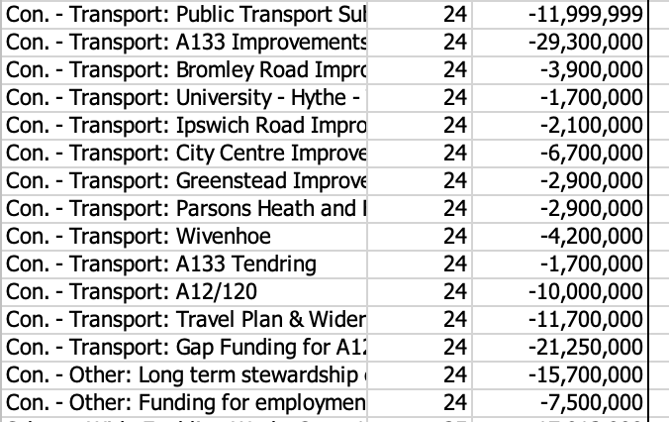

We clearly need a memorandum of understanding which ties Latimer into the scope of the project as defined in the IDFP and Gerald Eve appraisal.

Health provision: GC6 is vague and GC9 provides no further comfort. Well defined targets are needed, as with education where there is a well-established formula for the number of school places required. The developer needs to be committed to providing new surgery buildings, and we need something in writing from the NHS about funding for new staffing. At the Section 1 Inspection we heard high level strategic statements from the NHS about new models for primary care delivery. Interesting though these are they shouldn’t replace solid plans for delivery.

We can’t expect communities to support development if their existing over-stretched health facilities are to be further diluted.

HIF Agreement: GC9 requires applicants to comply with the conditions of the Housing Infrastructure Fund, but these are laid out in a secret document to which Colchester’s Councillors have no access. It isn’t clear how a sound plan can incorporate secret requirements such as this.

Homes England have refused a Freedom of Information request for the HIF agreement, arguing that publication is against the public interest, a position that should be challenged: if it must remain secret then the plan must refer to each relevant requirement rather than the document as a whole.

Contributions to the link road: the cost over-runs on the link road and Rapid Transit System are also secret and fundamental to the plan. Their disclosure is in the public interest and the Inspector will need to understand them. I suggest that the details be published, with some redactions for commercially sensitive negotiations, eg for current land acquisition negotiations.

Monitoring: the DPD suggests that this 35 year project can be monitored through 15 worthy social objectives (page 132). Many will be difficult to measure in practice and responsibility will be hard to allocate: for example who is responsible if crime rates don’t fall? And there can be no sanction if they are not achieved.

I suggest more tangible targets focussed mainly on practical infrastructure delivery. If these are achieved the social objectives will follow.

Infrastructure monitoring can best be done by breaking the project into phases, as with every other new town development I can find (see appendix 1). The Councils can retain some control by insisting that the promised infrastructure for each phase is delivered before the next phase is permissioned.

Compromises: my appendix 2 shows that the scheme isn’t financially viable at present – it was always marginal and recent increases in build costs and interest rates together with lower house prices put it clearly under water. So compromises will be needed. It may be that the offsite transport schemes are funded from elsewhere or that the social housing numbers are moderated. It is clear that the plan isn’t compliant with national planning policy (the Viability PPG) until the situation is resolved.

Delivery
There have been many attempts to deliver large new towns in the UK, but very few successes. Recent history is littered with high ambitions and many failures as described in Appendix 1.

TCBGC could easily be added to the list of failures because:
- It doesn’t own the land and there is no mechanism for Land Value Capture.
- It is effectively an urban extension for Colchester built in Tendring – the benefits are enjoyed by one while the risks are piled on another, creating significant political pressures.
- It doesn’t have the external focus or commercial leadership needed.

Appendix 2 explains why the viability evidence is inadequate. The numbers show that the DPD is NOT financially viable, especially now that we have higher interest rates and build costs and lower house prices.

Appendix 3 explains Colchester’s proposal for a phase 1 appraisal and how we need to come to terms with the compromises that will be needed.

Appendix 4 shows that the land is not owned or controlled by the Councils

Appendix 5 shows that, according to the Gerald Eve numbers, the developer will have to pay £341m in infrastructure contributions to various public and private sector bodies.

Appendix 6 shows that Latimer’s balance sheet and track record are too small for a project of this scale without phasing and a parent company guarantee

Appendix 7 gives two examples of large projects which are being delivered in phases. Both Alconbury and Welborne have had to compromise on social housing and TCBGC is likely to have to do the same.

Conclusion
These appendices provide clear evidence that delivery of a 7500 dwelling community is a rare achievement and that TCBGC is a long way from having a credible plan. The DPD is a wish list which can’t be delivered without significant compromises, and it would be folly to take it further without addressing them.

William Sunnucks MA ACA MBA
Colchester City Councillor
24 June 2023

Page 49 of the Section 1 plan.
The HIF bid assumed 1000 homes could be built before the link road was operational. But there has been more recent talk about 4000 - we don’t know what is in the HIF agreement. In my view no new dwellings should be occupied before the link road is complete. This stretch of Clinghoe Hill/A133 is already under stress.
https://www.gov.uk/guidance/viability#viability-and-plan-making “Plans should set out the contributions expected from development” “Policy requirements should be clear so that they can be accurately accounted for in the price paid for land.” “The role for viability assessment is primarily at the plan making stage.”
See the Essex Developers Guide

