Appendix 3
From: William Sunnucks, CCC
To: Rob Smith, Hyas
18/4/2023

Dear Rob,

TCBGC – Phase 1 Appraisal and further MoU

I’m happy to provide the clarifications you have requested and to expand on the additional paragraphs in the Colchester resolution. And I’m pleased that Gerald Eve have been appointed to advise on the negotiation / commercial strategy. I have had no access to them or any other professional advisers, so I offer my suggestions as a straw man to be considered and burnt when more expert views are available.

Background
On 23rd March 2023 Colchester City Council approved the DPD as drafted, with the addition of two extra paragraphs as follows:

This Council:
(1) will seek to work in collaboration with Tendring District Council and Essex County Council to agree a further Memorandum of Understanding with Latimer in relation to the delivery of infrastructure across the whole development with a focus on phase 1, ideally before the consultation period starts. This is intended to agree an open book appraisal methodology, acknowledge a phase 1 appraisal to be prepared and agree the principles for delivery of all infrastructure. The Council will also request the appointment of an independent consultant to commence initial negotiations in respect of draft heads of terms for any future S106 agreement.
(2) expresses its strong concerns about the risk of congestion should phase 2 of the A120/A133 Link Road be delayed.

This note answers a series of questions which you have forwarded to me (presumably from Gerald Eve) and I hope it will be helpful in explaining the extra work needed. The subject is complex and easy to misunderstand, so I would welcome questions and corrections where I have made mistakes. Nothing in it need be confidential and I would not be embarrassed if Latimer were to see it.

What is the amendment seeking to achieve?
The extra paragraphs are intended to make the Garden Community more deliverable. They were needed because, although the scheme has the potential to be financially viable, we don’t own the land and at present we don’t have any practical plan to capture the uplift. The DPD is likely to fail at Inspection unless it is supported by a credible commercial strategy.

I list below how a phase 1 appraisal will help overcome the current weakness:
- The current approach postpones serious discussion of land value capture until the planning application stage. A phase 1 appraisal will start to address it at the DPD stage when our commercial position is stronger.
- The current approach appears to envisage one big planning application for 7500-9000 dwellings over 35 years. A phase 1 appraisal points to multiple phases which are more in line with Local Plan timescales, each with its own planning application and s106 agreement.
- The counterparty, Latimer Developments Limited, has net assets of just £53m. The total cash commitment for external infrastructure will be £300m or more under the current approach, many times more than can reasonably be promised by Latimer alone. The Councils will need to see further equity and a Clarion guarantee which may be challenging given the risky nature of the property development business. An initial phase 1 approach will reduce credit risk and be in the interests of both parties: the Councils will be in a stronger position to negotiate future phases and retain financial control: and it will reduce the capital demands on Latimer.
- Both the quantum of a mega s106 agreement and its duration would be outside the normal range under the current approach. It will be a 35 year project in which the developer will have overwhelming commercial leverage because it controls the land.
- A phase 1 appraisal will be technically more robust. The Argus Developer appraisal software used by Gerald Eve is (in my view) inappropriate for a 35 year project. Implicit in the software is an assumption that generates interest charges which are £37m lower than the Hyas equivalent. It will be difficult to defend this approach if it is challenged by the developer during the s106 negotiation. The best remedy is i) to use IRR as the key metric rather than profit on cost and ii) to work with a 10 year model where the problem is less prominent.

Key principles for the s106 negotiation
For harmonious relationships and commercial credibility it would be helpful for both parties to agree the following key principles for the s106 negotiation now:
- Open book appraisals to be prepared in line with the Viability PPG
- Agreement on the phasing of planning applications. I understand that one big application contemplated, presumably supported by one mega s106 agreement. I have looked at such a document for the Garden Community at Welborne and it is complex. It would be quicker, simpler and cheaper (in terms of legal fees) to have a separate application for each phase, supported by a separate s106, within the overall masterplan framework.
- Provision for periodic reviews to ensure that a share of any excess profits (quite possible if inflation continues and cash doesn’t run out) is collected by the Council to be invested in further connected infrastructure
- Whether to have a two-tier appraisal approach for controlling the project – the Gerald Eve appraisal assumes a master developer (one tier) who sells plots to housebuilders (a second tier). In practice Latimer is hoping to build 2/3rds of the housing itself, so an agreed hybrid appraisal approach may be more appropriate.
- What land value assumptions to use in the appraisals. Under the Viability PPG the actual amount paid for the land is irrelevant: Latimer needs to acknowledge that the appraisal will use no more than £50-100,000 per acre, paid over the project period – it makes a huge difference if the land must be purchased on day 1.
- Agreement of the other assumptions behind the phase 1 appraisal
- Agreement on the principles behind the infrastructure delivery plan.
- Agreement on the key metrics to be used to determine viability. I would argue that pre-interest, pre-tax IRR works best, and that the target range should be 10-14% as suggested by Gerald Eve.

Professional support:
It is vital that the Councils have independent written advice on the issues above from someone experienced in s106 who understands both the economics and the legal framework. I hope that Gerald Eve will be able to provide that strategic commercial advice – something similar to the PWC report on the NEGC project.

If there is to be just one huge section 106 agreement for the 35 year project a top legal team should be engaged and a substantial budget set aside for the fees. Hundreds of millions are at stake so it would be well worth planning the legal strategy in advance. It would be wrong to try to shoe-horn the legal budget into any contribution offered by the developer and I repeat that it would be cheaper and safer to negotiate 10 year agreements.

Consideration should also be given to governance surrounding the negotiations. Councillors cannot be directly involved, but they bear responsibility for the outcomes and should have access to advice and be allowed to contribute indirectly. It may be that a subcommittee of those with financial or legal experience is needed.

The timing of S106 negotiations
It should be possible to include the points above in a non-legally binding Memorandum of Understanding before the reg 19 consultation starts.

We should also prepare a phase 1 appraisal before the consultation starts so the public can see what compromises are needed – see below.

In due course I would expect the MoU to be developed into a draft s106 agreement to support the phase 1 planning application. The s106 for a 10 year project will be an altogether more straightforward document than one for 35 years.

There may be a desire for secrecy and gamesmanship in the negotiation. However I doubt that such cleverness will succeed, and an open book approach is (i) healthy, (ii) convincing for an Inspector and (iii) sets an example for the developer.

None of this should be unacceptable to the developer - in their shoes I would see it as a net benefit. The total project will be undiminished, but the capital commitments will be reduced and the reg 19 consultation will provide useful feedback on infrastructure priorities.

Scope and wording of the MoU
The MoU would
- Agree the s106 principles laid out above
- Agree to adhere to the Inspector’s advice on appraisal methodology
- Comment on the status of both the 35 year and phase 1 appraisals
We cannot expect Latimer to agree specific numbers at this stage, but agreement of the principles will be helpful to all parties going forward and convincing at the Inspection.

Phase 1 viability modelling
Definition of phase 1: more work is needed to align the IDPF and the Gerald Eve phasing, and to define a consistent phase 1.

For the purposes of this exercise I ignore the IDPF phasing, and use the columns in the Gerald Eve appraisal instead. This is arithmetically convenient and is adequate to illustrate the principles. .

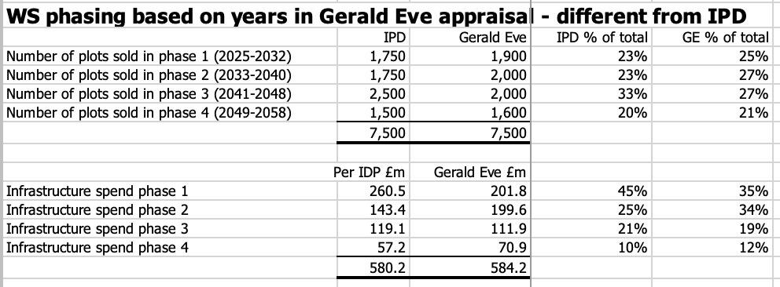

I assume a phase 1 cut-off in 2032 after the delivery of 1900 housing plots. The cash deficit is then at a minimum then and it coincides broadly with the end of the Section 1 plan period.
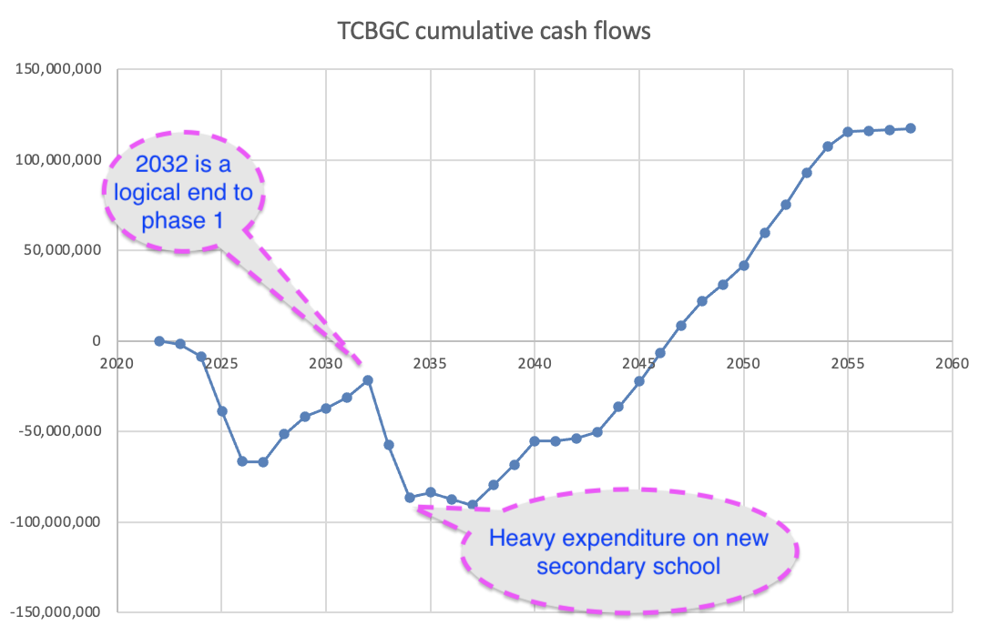

Viability of phase 1: a phase 1 appraisal which simply deletes all columns after 2032 produces an IRR of just 1.64%. But some expenditure in 2030-33 clearly relates to phase 2, and adjusting for that increases the phase 1 IRR to 5.74%:
Allocate 2032 land purchase to phase 2 £3.5m
Allocate 2031 education spend to Phase 2 £6.6m
Allocate 2030 community spend to phase 2 £2.3m

Compromises: compromises will be needed and this is where the project comes to life. We will only have a deliverable project when we have a workable control system and compromises to be made – otherwise we have little more than a wish list. The stage 1 appraisal will be an effective control and we can test a range of alternative compromises against it.

I have modelled one particular set of assumptions to increase the IRR to 11.8%. Note that this is just an illustration to show how numbers can be used in the planning process.

Some possible compromises to increase the IRR to 11.8% - for illustrative purposes only:
Remove front ending of utility expenditure £8.3m saving for phase 1
Postpone some transport schemes to phase 2
* University - Hythe – Town £2.7m
* Ipswich Road Improvements £1.7m
* City Centre Improvements £6.7m
* Greenstead Improvements £1.7m
* Parsons Heath and Fox Street £2.1m

These are allocations between phases, not cancellations, and there is no reason why the phase 2 work can’t run in parallel to phase 1 if the developer so wishes. The phasing is to be used as a disciplined control mechanism which grants planning permissions supported by legally binding infrastructure delivery commitments for each phase.

The Link Road
The Gerald Eve appraisal assumes that the £21.25m gap funding for the link road will be paid in 2027. It was prepared before the news about the phased approach came through and it isn’t clear whether £21.25m will be sufficient. CCC has expressed “strong concerns” about the risk of non-delivery, and I hope someone will ask the Inspector to modify the DPD to include additional protections such as:
- no planning permissions for housing until delivery of the link road is certain
- no housing starts until both phases of the link road are started, and/or
- no more than 1000dwellings occupied before the link road is completed.

Further cost over-runs on the link road will mean that savings will be required elsewhere. The Inspector will need to see the costings and understand the HIF agreement, neither of which are currently visible to Councillors.

Conclusion:
I hope that this note shows how a phase 1 appraisal could be used and how it leads to a credible commercial strategy. It was discussed with senior Colchester Councillors from all parties (including the Mayor, the portfolio holder and two former Council leaders) and the detailed wording was discussed with several officers including Karen Syrett, Andrew Weavers and Steve Evison. It now has the support of the full Colchester Council and I hope that other Councils will understand and support it too.

I don’t expect my suggestions to be followed exactly but I hope they will increase awareness of the Councils’ weak commercial position and significant risk of failure at Inspection.

William Sunnucks MA ACA MBA
18/4/2023

Argus Developer implicitly assumes that developer profit is extracted from the scheme towards the end. Housebuilders might be prepared to wait 10 years, but 25 years plus would be unprecedented. £1 of profit in 25 years at a discount rate of 7.5% would be worth just 16p now. It is wrong to compare present and future values without discounting to NPV.
Hyas interest charge for its closest case was £120m. Gerald Eve interest charge £82.9m. Difference 37.1m.
The IDPF grosses up the £100m HIF Grant and excludes fees and contingency. There are some other differences in particular on the timing of the electricity connection. Phase 1 delivery of 1750 homes doesn’t fit neatly with the Gerald Eve years.
The HIF bid assumed 1000 homes could be built before the link road was operational. But there has been more recent talk about 4000 supported by more optimistic assumptions about usage of the Rapid Transit System.

