Appendix 2
TCBGC Financial Viability

Introduction
This note demonstrates that TCBGC isn’t financially viable on the evidence provided. It leads to the conclusion that the DPD should be paused until the financial matters are addressed for phase 1 and documented in a further Memorandum of Understanding – as requested by Colchester’s full Council in a formal resolution.

The appraisal approach (and the need for a phase 1 appraisal)
The viability evidence relies entirely on a 35 year development appraisal. Gerald Eve talks about “the market” and suggests that such projects are regularly undertaken and that their approach is in some way “normal”.

In truth a 35 year development appraisal is a theoretical construct – interesting but not a practical plan. There is no “market” for bank funding for speculative development over 35 years. It is easy to obtain long term funding for an investment property already built with a good tenant in place. But from a bank’s viewpoint TCBGC is high risk, and lenders would want opportunities to recycle their money after no more than 5-10 years.

This statement is based on my career as finance director for big organisations with responsibility for Treasury Management amongst other things. I have been constantly talking to banks and investors about development finance since my first position as finance director of a listed company in 1989.

I back it up with a list of new town projects at appendix 1 – few have succeeded and those that have are clearly developed in phases of no more than 10years. Despite the hype they have also been slow to deliver significant numbers of dwellings. I also present an analyst’s report explaining how Urban and Civic is funded, a master developer with real credibility and track record which is now owned by the Welcome Foundation.

We desperately need a phase 1 appraisal to bring the project down to earth over the plan period. This is in addition to the overarching 35 year appraisal, not in its place. Colchester asked for a phase 1 appraisal in a formal resolution by the full Council – Appendix 3 is a note to Gerald Eve explaining the resolution. Unfortunately their paper in response shows many misunderstandings and I have not been allowed to talk to them to find common ground. A meeting is scheduled shortly after this consultation closes.

Appendix 7 shows how a similar viability problem was resolved at Welborne in Hampshire - by cutting social housing to 10% in the first phase.

We also need a further MOU with the developer agreeing the appraisal methodology. Residents cannot understand why the Councils are spending time and money on planning for someone else’s land. And are incredulous when they hear that there is nothing in writing – no contract, no MOU, no agreed mechanism for the sharing of land value uplift.

If the DPD is adopted the Joint Committee will still have the right to turn down any non-compliant application. But in practice they will have no choice but to agree to whatever compromises are required by the developer.

House prices
GE assume that houses can be sold for £400psf with social housing discounted by 50% and shared ownership by 30%. GE’s own evidence about the local market shows that the average selling price is £338psf. Only one development has exceeded £400psf and that is Chesterwell at £410.

I would expect TCBGC to be slightly above the average but not as high as £400: it will sell better than the developments to the South of Colchester where the infrastructure is particularly poor, but we shouldn’t forget that Tendring prices are in general lower than Colchester. Also that house prices have probably been unusually high in recent years due to Quantitative Easing. It is too optimistic to rely entirely on one comparator especially when house prices are clearly falling.

The land registry statistics quoted by GE are already showing a significant nationwide decline and a smaller one in Colchester. House prices have been unusually high over recent years due to Quantitative Easing and low interest rates. It will be important to re-look at the figures just before the Inspection.

House price indices
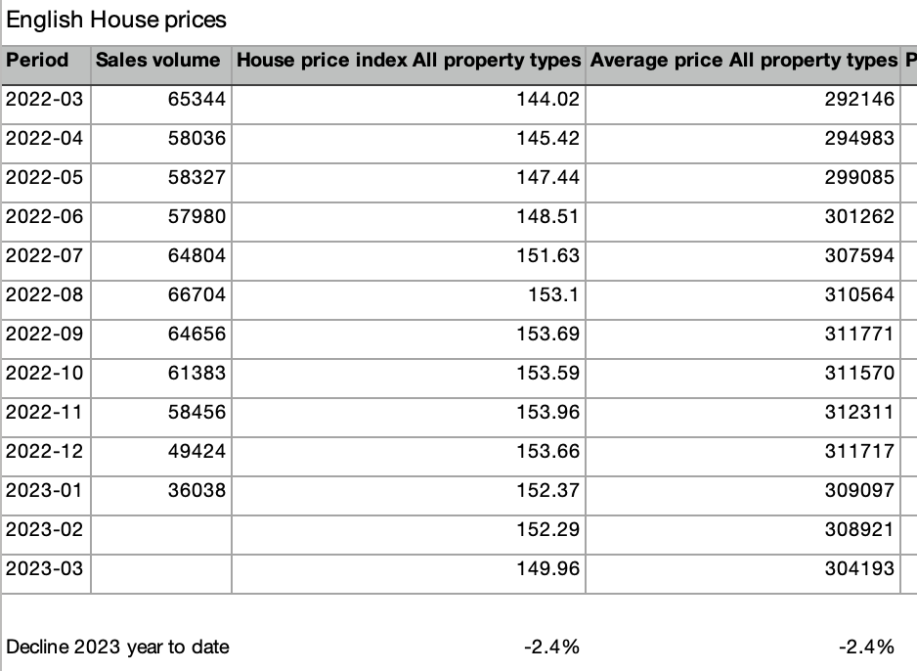 | 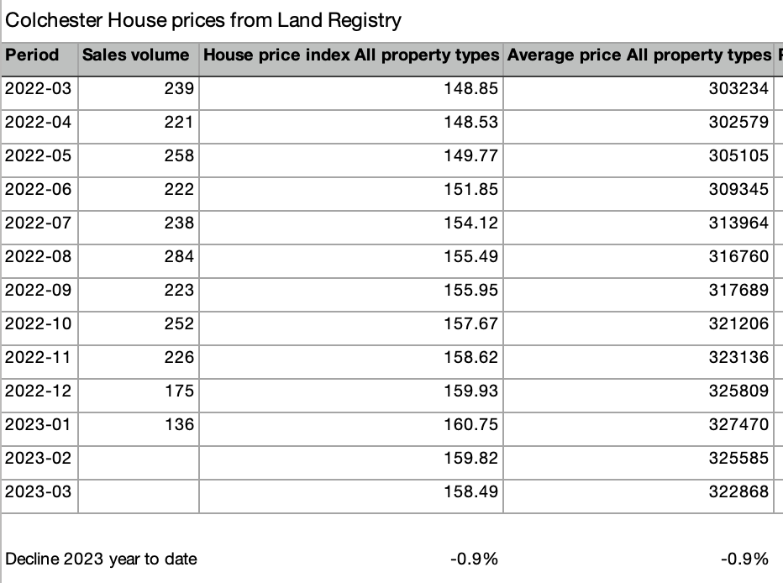

The viability model is super-sensitive to house prices because the operational leverage is high. A 10% reduction in house prices creates a 26% reduction in plot values and reduces the master developer IRR from 9.8% to 0% (using figures from my model).

See the sensitivities table below. I’m not suggesting that there will be a 10% decline in house prices, but it isn’t impossible especially alongside the 30%+ reduction we have seen over the last year in commercial property values.

Residential plot prices.
The model assumes that residential plots can be sold to housebuilders at £104,000 per plot. This is supported by the housebuilder appraisal presented on page 94.

£104,000 looks high. Urban & Civic were selling serviced plots in 2022 at £89,000 apiece, much less than is proposed for TCBGC. And many of them will have been at Alconbury which is a stronger housing market in the Cambridge area.

Gerald Eve needs to provide supporting evidence from Alconbury or elsewhere that housebuilders are prepared to pay £104k per plot in practice, especially with 30% social housing and demanding build requirements. The housebuilder appraisal shows it can be done in theory, but are they paying that much in practice?

Commercial plot sales (B2/B8)
GE have assumed rents of £16psf based on one transaction in Wyncolls Road (page 132). I know this market and it is highly likely that the Developer will be able to demonstrate a lower figure when negotiating s106. Reducing it to £14psf would reduce the IRR from 9.8% to 9.34%.

Contingency
The GE appraisal provides contingency of just 12.7%. This is a blend of four tiers of contingency –
- 0% for cash contributions e.g. to stewardship or the Link Road,
- 10% for Education, open space and scheme wide enabling works
- 20% for many of the transport schemes
- 40% for utility connections

The 2020 Inspector’s report pointed out that the Treasury Green book requires 44% contingency for optimism bias on civil engineering items (para 217). He also warned about cost over-runs on the RTS (para 218) and advised that it would be reasonable to expect a contingency allowance of at least 40%. “Any lower figure would, in my view, provide insufficient reassurance that the necessary infrastructure requirements of the proposed GCs would be met.”

TCBGC’s infrastructure is still poorly defined. The one item where we have real pricing data (the RTS and Link Road) has produced substantial over-runs – the exact figures have been withheld but they are rumoured to be around 42%. They go to the soundness of the plan so I would expect the Inspector to ask for them.

I believe, on the basis of good evidence, that it would be imprudent to provide less than 40% which reduces the IRR from 9.8% to 3.11%.

The table below shows the contingency applied by Gerald Eve alongside my figures. 40% needs to be provided on the £21.25m Link Road cost now that the developer is taking responsibility for phase 2, by far the most complex and expensive part. I could also justify adding 40% to professional fees and planning costs but haven’t done so.

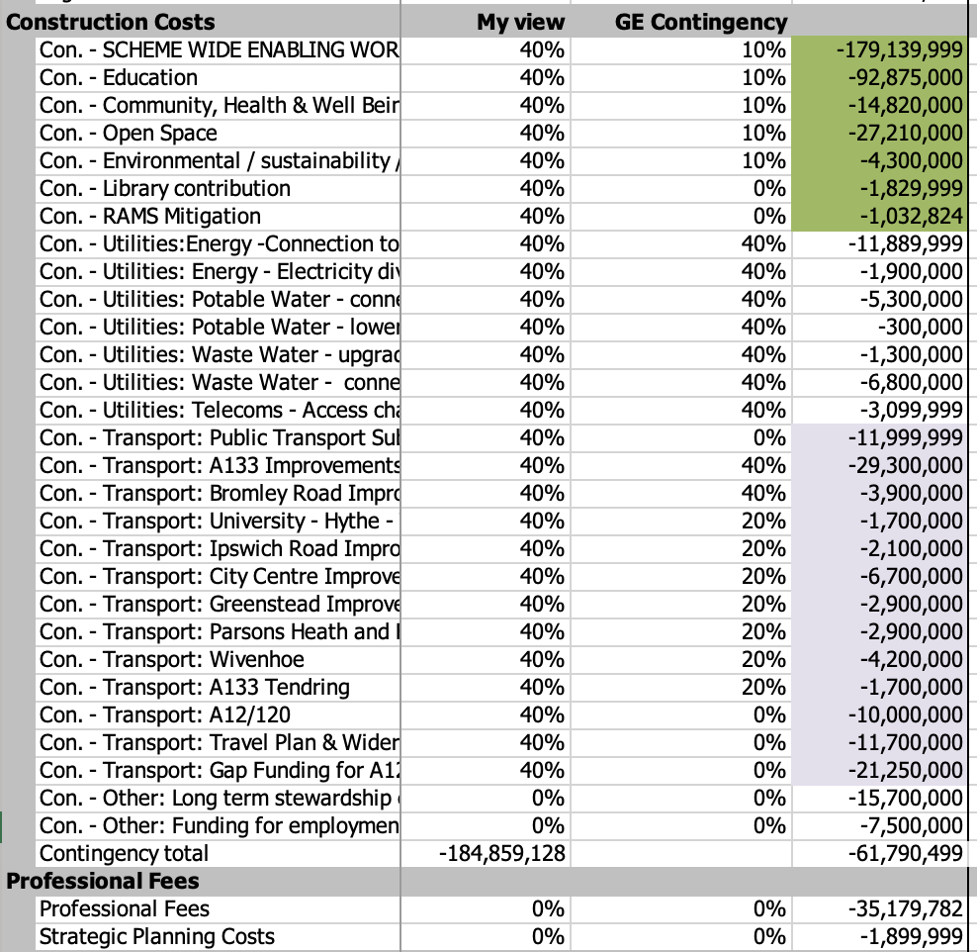

The finance rate
GE use a finance rate of 7.5% for both the housebuilder and the master developer appraisals. They mention WACC (the weighted average cost of capital) but don’t explain how the (much higher) cost of equity is factored in. It isn’t clear exactly what they are trying to measure.

Clarion lend to Latimer at SONIA + 5.5% = 9.5% a much more appropriate cost of debt especially when arrangement and exit fees of 1-2% each are included.

I fear that Latimer’s s106 consultants might be able to demonstrate that 9.5% is a reasonable finance rate for appraisal purposes in the current lending market. 9.5% would adversely affect the profit on GDV and residual land value metrics, but fortunately not the IRR.

The best solution is to concentrate on IRR for the master developer model, a figure that is unaffected by the choice of finance rate.

The interest calculation
The Gerald Eve appraisal generates an interest charge which is £37m less than the Hyas equivalent – a very significant amount. By way of background Hyas did the viability for both section 1 Inspections and their methodology stood up to scrutiny well in the January 2020 sessions. The interest charge in their most realistic case (TCB2C Grant 40% contingency) was £120m compared to £83m in the Gerald Eve appraisal which supports the DPD.

I looked into the difference and found that it arises from different assumptions about the timing of developer profit distributions, which are of course treated as a cost in calculating residual land values. GE assume that the profit is taken out at the end of the project whereas Hyas charge it as a cost over the project period.

I am not aware of any developer who would wait 25 years before receiving any profit distribution from a development subsidiary which it had financed, so I think that the GE approach is unrealistic. They will argue that they are using industry standard software and that their approach is in line with market practice. But the software is a tool which can be adapted either way: and they present no evidence that there is such a “market”. No reliance can be put on their interest calculation for the real world.

Once again the best solution is to concentrate on IRR in order to bypass the problem.

The metrics – IRR / residual land value / profit on GDV
Gerald Eve base their conclusions on three metrics :
- IRR or internal rate of return is a valid measure for a 35 year project
- Residual land value v. benchmark
- Developer profit / GDV is suitable for a housebuilder project of 5-10 years but seriously misleading for any number of reasons.
  - it commits the cardinal sin: it compares future profits to current costs
  - It deducts developer profit only at the end the project period rather than during it as in the Hyas 2020 appraisal.

I believe that the IRR figures are the only ones we should rely on for the master developer appraisal. Developer profit / GDV is appropriate for the much shorter housebuilder appraisals.

Growth modelling
Growth modelling has been suggested as a way out of the viability constraints. But if done correctly it will produce exactly the same results and real world providers of finance won’t be convinced by it.

Growth modelling attempts to include inflation and is useful for calculating peak cash requirements. But it is often done badly and thus it isn’t trusted. We saw growth modelling at the 2020 inspection producing wild figures over 50 years and drawing erroneous conclusions. Inflated future values were compared to current values, some items were inflated and not others (such as deferred land acquisition costs) and most significantly the benchmark IRR was not adjusted for the impact of inflation. My critique of these appraisals is available to anyone who is interested.

If growth modelling is to be attempted it must be done properly.
- All figures must be inflated, not just revenue
- The benchmark IRR must be adjusted upwards
- The tax consequences of inflation must be considered
- Future values must NEVER be compared to current ones

Sensitivities
I have adapted the Gerald Eve cash flow (for which many thanks) to calculate sensitivities. Each sensitivity refers back to the base case, and none reflects any particular views – they are just numbers.
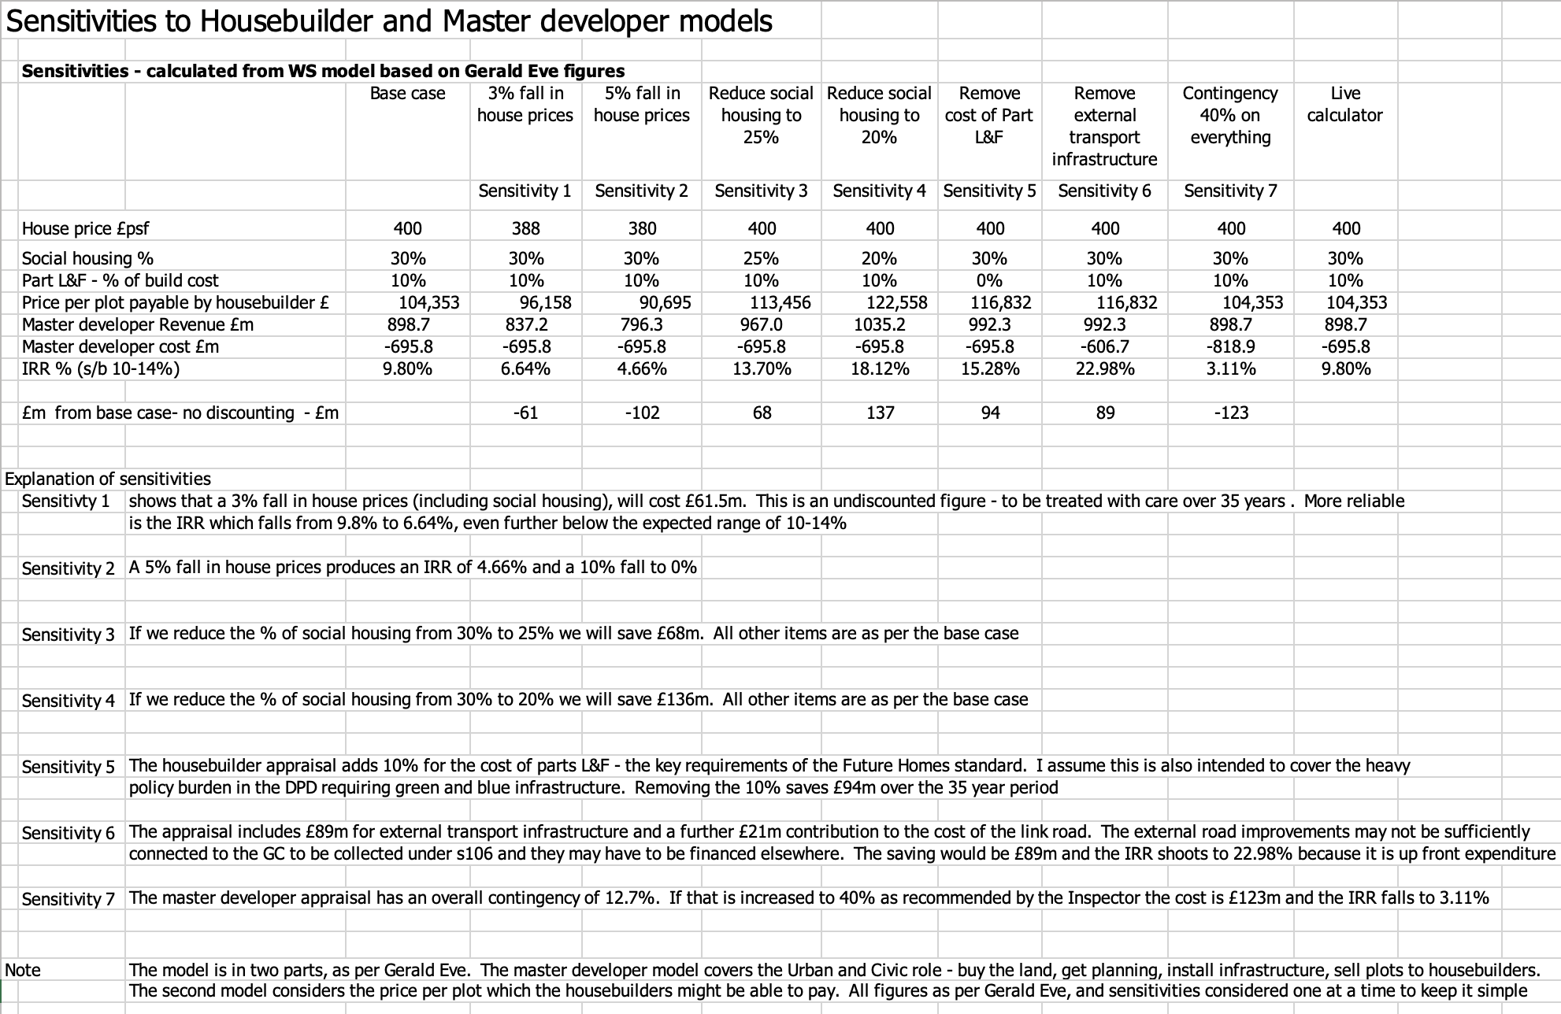

The figures show that viability is sensitive to house prices. Even a 3% reduction from the key £400psf assumption has a major impact.

They also give a view of the compromises that may be needed. The IRR should be in the 10-14% range but it is only 9.8%. And we know that the house price and contingency assumptions are optimistic and that compromises will be needed.
- 25% social housing saves £68m
- Removing environmental regulations saves £93m
- Removing all external transport infrastructure except the link road saves £89m
I am not endorsing any of these compromises, merely calculating the figures.

Is TCBGC viable?
Gerald Eve’s own numbers show that the project isn’t viable.
- The IRR of 9.65% is below the preferred range of 10-14%.
- The faulty developer profit / GDV metric is 13.4%, below the benchmark of 15%.
- They conclude that the project is “capable of becoming viable”, not that it is viable.

The GE numbers appear to have been prepared last autumn on the basis of backward looking evidence. Since then the position has clearly worsened but the appraisal hasn’t changed. House prices are now falling, and build costs and interest rates continue to rise. Also the total contingency (12.7%) is below the level advised by the section 1 Inspector (40%).

The DPD is not viable as it stands and compromises will clearly be needed, as they have on other schemes of similar size. I recommend focussing attention now on a 10 year phase 1 appraisal to demonstrate that the scheme will not be stillborn.

William Sunnucks MA ACA MBA
Colchester City Councillor
24 June 2023

Page 20 of the Urban & Civic 2022 annual report (which is available online) reveals that they generated £109m from the sale of 1221 plots giving an average of £89,271 per plot.
Note that my model is throwing up a very slightly higher IRR than Gerald Eve’s 9.65%. The difference is small - not worth chasing. It may relate to assumptions on the timing of cash flows within each year.
£62m contingency / £485m infrastructure cost = 12.7%. In addition there is a 3% contingency at housebuilder level. Some would treat developer profit as a further contingency but the Inspector advised against that in his 2020 report para 76.
Please see the appendix 6 which includes relevant passages from Latimers 2022 accounts.
In simple terms if 5% inflation is modelled then the benchmark IRR should be increased by 5%.
In the 1970s the tax consequences of inflation were a major problem and “stock relief” had to be introduced to reduce the impact of tax on inflationary stock gains. Some profitable companies were failing because they couldn’t afford to replace their stock at new and higher prices.

