Appendix 1

New Towns – the Track Record
The DPD shows little awareness of the practical difficulties of delivering a 7500 dwelling new town – they are treated as problems for the developer. We are expected to believe that development at that scale is commonplace, but it isn’t.

Any review of the recent history of new towns in the UK can only lead to the conclusion that TCBGC is unlikely to be deliver anything like the promises of the DPD.

New Towns
No new towns have been formally designated in England since 1970. The post war new towns, which included Milton Keynes, were built in a very different planning and legal environment where land value capture was easier, and the grip of environmental regulation markedly weaker. See https://en.wikipedia.org/wiki/New_towns_in_the_United_Kingdom

In 2007 the Government designated 10 new Eco Towns. None of these was built, and the idea was quietly dropped. Two morphed into garden communities (St. Austell and NW Bicester), but despite all the hype, Google maps reveals that scarcely anything has been built after 16 years. It is easy to get carried away by the big talk from Councils, professional firms and estate agents all of whom have an incentive to portray success and prosperity. Google maps tells the truth.

The more recent wave of garden communities has yet to reach scale, and seems likely to encounter many of the same problems.

Social housing
One common feature of these new towns is the low level of social housing. For example the early plans for St. Austell promised 40% but is delivering only 20% https://planetradio.co.uk/pirate-fm/local/news/west-carclaze-garden-village-concerns/

Appendix 4 provides further examples of low social housing shares due to viability concerns. Alconbury has 12.5%, and Welborne just 10% in the first phase.

This is important because it illustrates how, once the DPD is adopted, the Councils will be in the hands of the developer and will be forced to make compromises.

Credibility for TCBGC
If TCBGC is to gain public confidence it needs to demonstrate how it will succeed where others have failed. It can’t rest on precedent because there are few if any that have delivered anything like the promises in our DPD – 30% social housing, significant external transport infrastructure, expensive green and blue infrastructure within the settlement, no government support beyond the HIF grant.

William Sunnucks MA ACA MBA
Colchester City Councillor
24 June 2023

The vision – NW Bicester | The reality after 16 years
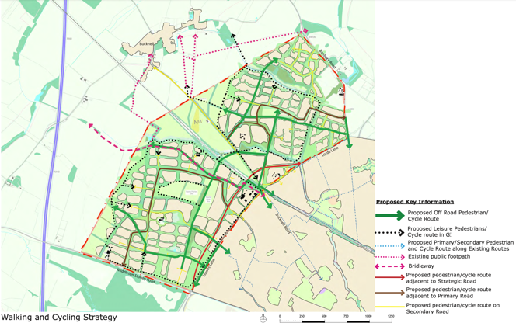 | 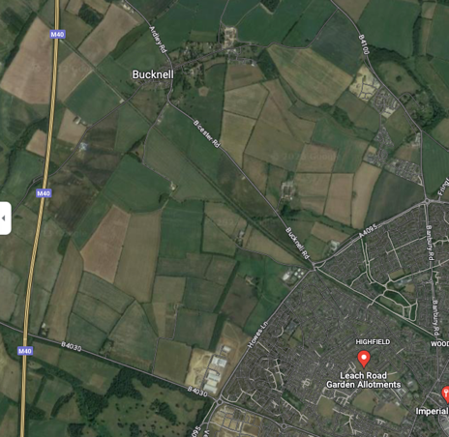
St. Austell - Cornwall | The reality after 16 years
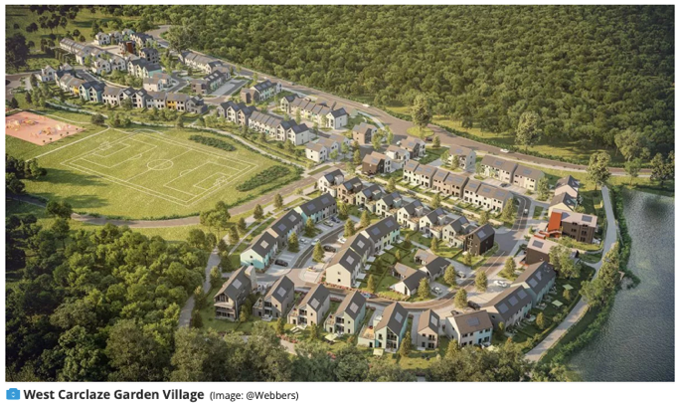 | 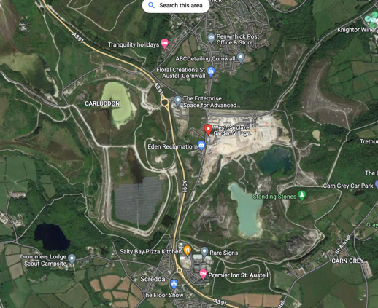

List of Eco Towns and comments on progress from the Architects Journal in 2009
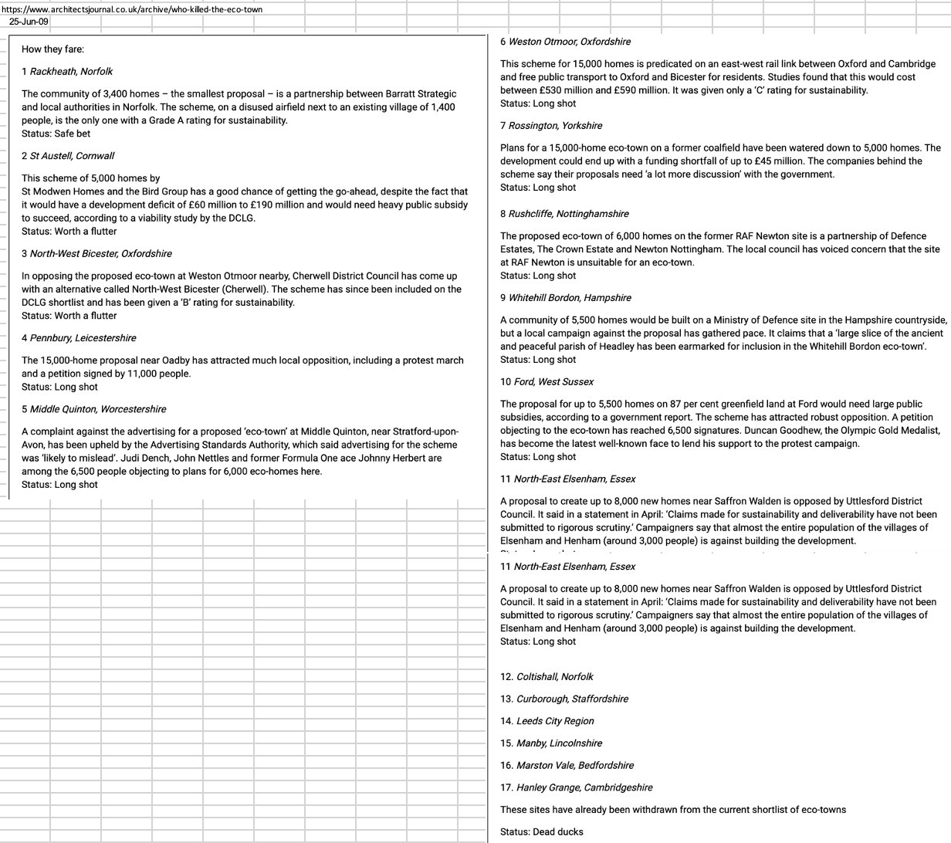

List of Garden Towns and Villages being funded by DLUHC in May 2022

